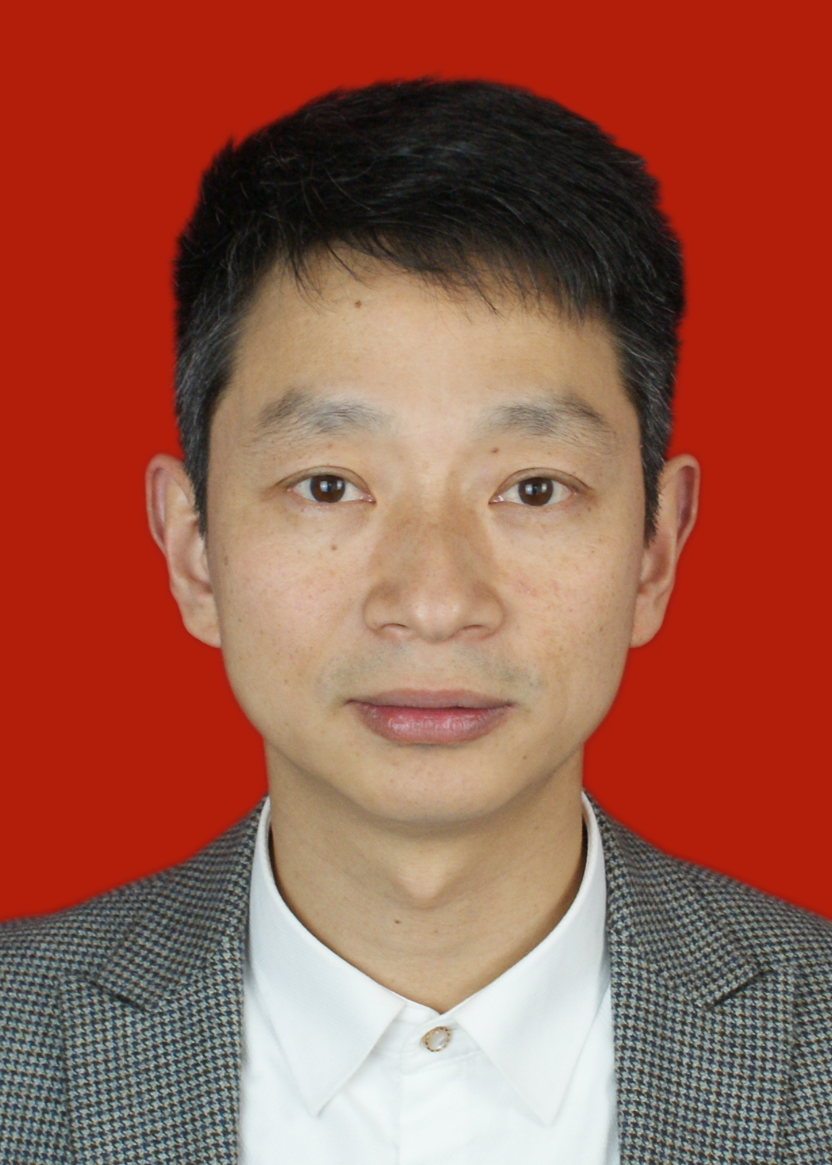 | Fan Min received the M.S. and Ph.D. degrees from the School of Computer Science and Engineering, University of Electronics Science and Technology of China, Chengdu, China, in 2000 and 2003, respectively. He visited the University of Vermont, Burlington, Vermont, from 2008 to 2009. He is currently a Professor with Southwest Petroleum University, Chengdu. He has authored over110 refereed papers in various journals and conferences, including the Information Sciences, the International Journal of Approximate Reasoning, and Knowledge-Based Systems. His current research interests include data mining, recommender systems, and granular computing.
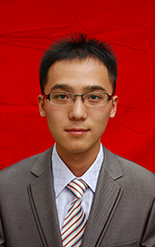 | Zhi-Heng Zhang is a Ph.D. candidate of Southwest Petroleum University, Chengdu, China. He received the M.S. degree from the School of Computer Science, Southwest Petroleum University in 2015. He was awarded the National Scholarship for Master Students in 2014. His current research interests include time-series analysis, three-way decision, cost-sensitive learning.
 | Wen-Jie Zhai is a graduate student of Southwest Petroleum University, Chengdu, China.  His current research interests include time-series analysis and artificial neural networks.
 | Rong-Ping Shen is a graduate student of Southwest Petroleum University, Chengdu, China. Her current research interests include recommender systems and sentiment analysis.

